# Source control plan

* We will use GitHub for source control management. The designer will contribute design/docs to the repository in a designated folder.
* The programmer will contribute code and will notify the artist where assets should be placed in the project.
* The artist will create assets and place them as indicated by the programmer within the repository.
* The tester will download a release from GitHub at each of the testing milestones and report on their findings in the “issues” section of the repository.

# Project plan

Attached is a project plan for this project, created in Microsoft Project 2016

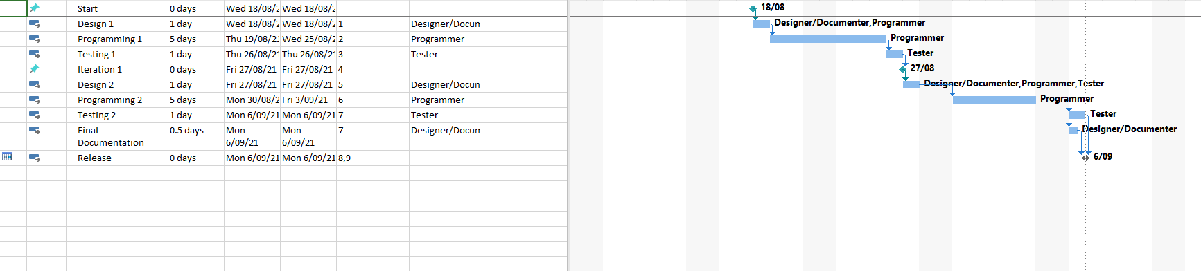

# Collaboration Assistant

The team will be collaborating and managing tasks with the aid of Trello, as shown.

<https://trello.com/b/0wlVHCfx/tetris-development-plan>

